- INTRODUCTION

  - The purpose of this standard procedure is to establish a method for the review and forecasting of cash requirements for the sample worksheet F-900a.

- CONCEPT

  - Cash planning is one of management’s most important, ongoing duties. The budgeting of incoming and outgoing cash results in the following benefits:

  - It gives management an early warning of upcoming difficulties with cash availability.

  - It shows management when a surplus of funds will be available for other than operating use.

  - It provides a plan for payments to creditors that are balanced with receipts.

  - It indicates the need to step up collections activity if accounts receivable payments are lagging.

  - It demonstrates to lenders that management is informed as to the financial requirements and has planned to meet the company's obligations.

  - As per our discussions, your QuickBooks™ program does provide cash flow forecasting capabilities (go to the “toolbar” and select “Reports”, then Company & Financial, then “Cash Flow Forecast” report). The standard report will provide a four (4) week look into the future. While the functionality is not robust, the standard report can be filtered and tweaked. In the end, the MS-Excel™ designed worksheet is a stronger analytical option; however, the trade-off is that there is some manual input of data both upfront and on an on-going basis. Despite some manual input and considering the importance of this business process, the MS-Excel™ option should be strongly considered.

  - When selecting the MS-Excel™ option, because there is a fair amount of up-front data entry, a fairly simple “work around” should be followed. In QuickBooks™ utilize the functionality to export to MS-Excel™ your current vendors (for A/P activity) and current customers (for A/R activity). Next, “cut & paste” these company names to column “A” in F-700 Cash Flow Forecast.xls in the appropriate worksheet tabs and place in the Vendor Name and Customer Name columns respectively. This should trim down a lot of the data entry.

- DEFINITIONS AND FUNCTIONS

  - Cash Available is computed by adding together the following sub-divisions:

  - Beginning Balance: the actual total of all reconciled bank accounts and cash on hand. For subsequent weeks, the beginning balance will be the same as the ending balance from the previous week.

  - Accounts Receivable Payments: the payments that can be realistically expected in a given week based upon invoice dates, customer paying habits and your experience.

  - Other Cash Available: any outside sources of income, lines of credit, personal sources, etc.

  - Cash Requirements is the total of all cash expenditures for a given week.

  - Ending Balance is calculated by subtracting the total cash requirements from the total cash available.

- WORKSHEET PREPARATION

  - Open the MS-Excel™ worksheet titled F-700 Cash Flow Forecast.xls and click on the first worksheet tab titled “Accounts Payable Activity”. List all Vendors’ outstanding payables and their open balances in the appropriate columns. Project the amount in the weekly “bucket” in which the supplier(s) will be paid.

  - The colored cells contain formulas that are critical to the functioning of the worksheets. DO NOT ENTER DATA IN THE COLORED CELLS!

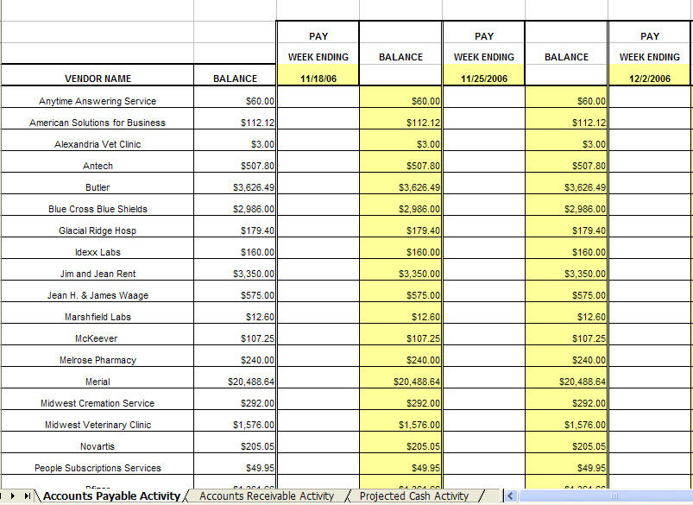
Figure 1

  - Next go to the second worksheet tab titled “Accounts Receivable Activity” and list all outstanding Customers’ receivables and their open balances in the appropriate columns. Project the weekly “bucket” in which you expect the customer to remit payment for the outstanding invoice.

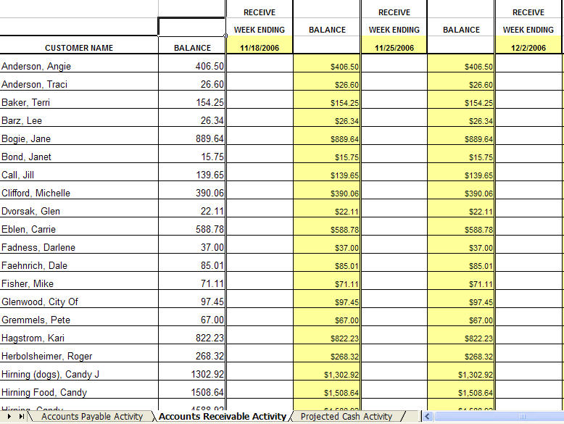
Figure 2

  - The third worksheet, titled “Projected Cash Activity”, integrates both the payables and receivables on a forecast worksheet that also lists your beginning checking account balance along with non-invoiced payables such as payroll, insurance, utilities, note payments etc. If there are instances of COD payments to specific vendors, list them here. You will be able to establish history and be capable of analyzing trends for COD payments if they apply to your business. Enter all other non-invoiced payables here and project the amount in the weekly “bucket” in which the outlays will occur.

  - The first two consecutive columns headed "Forecast" and "Actual" represent the current week of cash flow. Each week's cash flow is headed with the words "Week Ending" and the ending date (Saturday) of the week to be forecast.

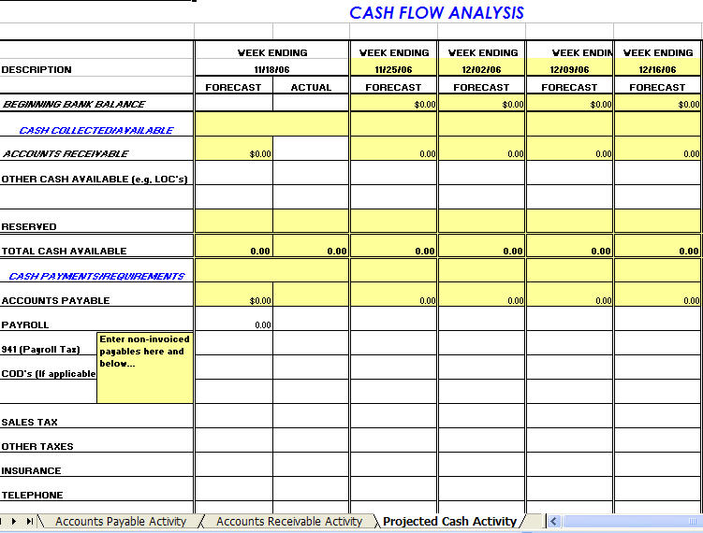
Figure 3

- PROCESS

  - The Cash Flow Forecast for the company is to be prepared and updated on a weekly basis. As each week is completed, the first Forecast week is copied to the first Forecast column and the date changed to match.

    - This will change the dates in all the worksheets and add another forecast week to the end of the schedule. This gives company management six weeks of forecast at all times.

    - On the Projected Cash Activity Sheet the Beginning Balance cell should NOT be copied. Type the next week’s amount in that cell into the Forecast beginning balance cell to transfer that data.

    - This process is repeated with each of the other worksheets so that the Payables and Receivables are correct on the Projected Cash Activity sheet.

  - The last forecast week is then edited in all the sheets as detailed in Section 4 above.


Figure 4

  - For each week on the forecast, an estimated amount is automatically posted to each receivable and payable in the "Forecast" column for the other worksheets.

  - At the end of the current week, the actual amounts for each Receivable and Payable are posted and forecasts for upcoming weeks are then adjusted.


Figure 5

- USE

  - When all the forecast columns have been totaled and a negative balance occurs in the ending balance, management must prioritize payments of cash and move selected payables to a future week. Negative balances are displayed in red font to highlight the issue.

  - Other options in this situation are to ensure the prompt collection of receivables or to borrow cash (use the Line Of Credit) to accommodate outflow requirements.

  - Delay of a payment should always be communicated to a vendor.

- SUMMARY

  - A regular analysis and review of the cash flow will promote tighter control of the liquidity and enable ownership to plan for meeting the obligations of the business in the most prudent and expeditious manner. It will also eliminate the classic surprise “cash crunch” and the associated stress on employee and vendor relations.

